**SHACMAN X3000 6X4 DUMP Truck自卸车**

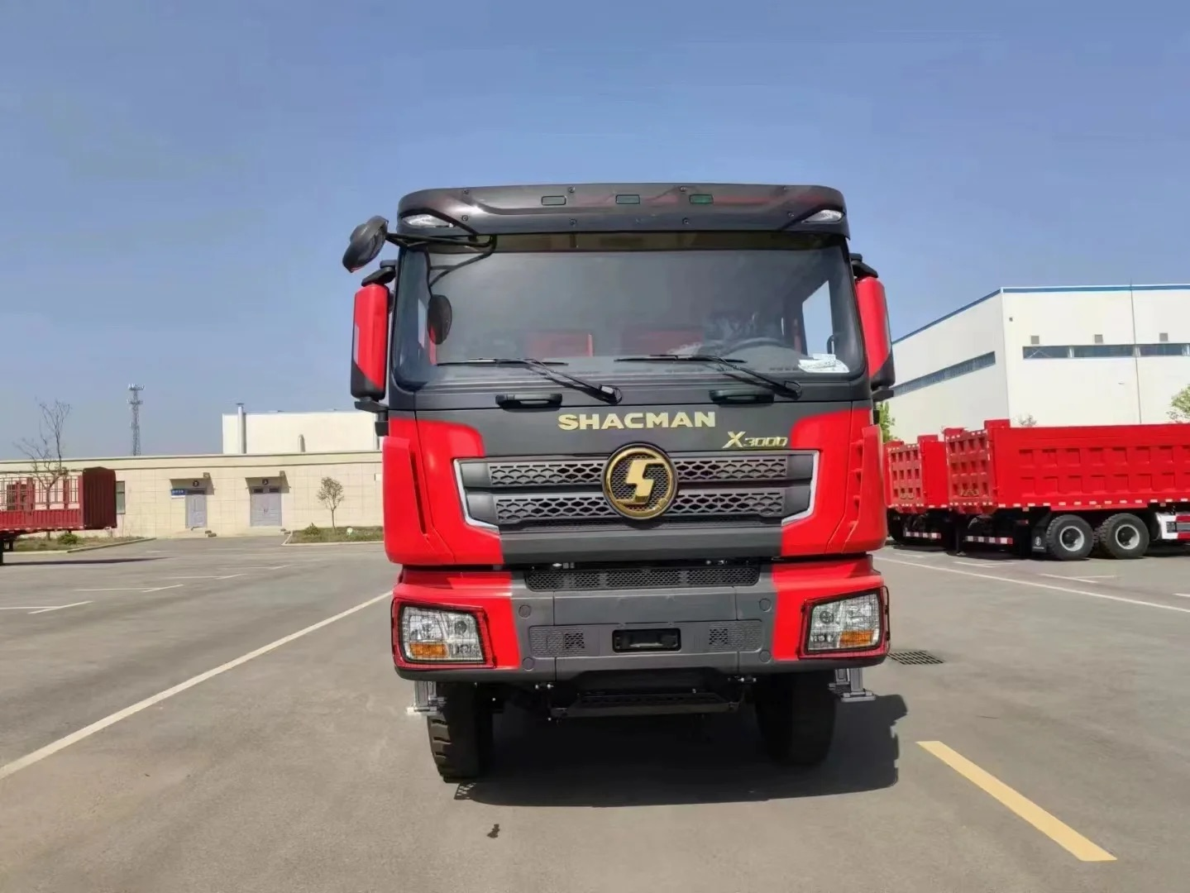

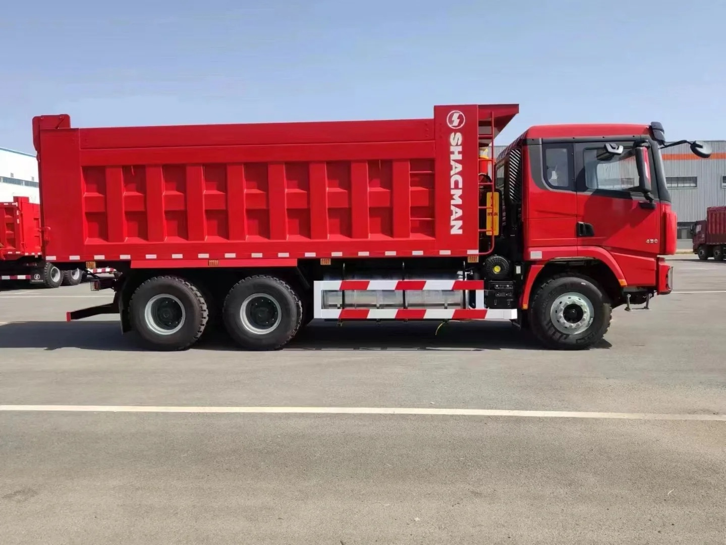

图片仅供参考

Pictures are for reference only

**Main Specifications主要参数**

|  |  |  |
| --- | --- | --- |
| MODEL/车型 | | SX32556T404 |
| Driver position/驾驶员位置 | | 左舵 Left Hand |
| Driving type/驱动形式 | | 6*4 |
| Wheelbase/轴距(mm) | | 3975+1400 |
| Max. Speed/最高车速(km/h) | | 75km/h |
| Engine/发动机 | Brand/品牌 | WEICHAI/淮柴 |
| Model/型号 | WP10.380E22 |
| Emission Standard/排放 | EURO II |
| Rated output power/功率（PS） | 279KW/380HP |
| Displacement  (L)/排量 | 9.726L |
| Transmission/变速箱 | Brand/品牌 | FAST/法士特 |
| Model/型号 | 12JSD200T-B-铁壳-QH50 |
| Front axle/前轴 | Brand/品牌 | 汉德牌/HANDE |
| Model/型号 | MAN 9.5T |
| Rear axle/后桥 | Brand/品牌 | 汉德牌/HANDE |
| Model/型号 | 16T MAN双级铸造桥 double reduction driving axle  Speed ratio 速比：5.92 |
| Clutch/离合器 | | ￠430 diaphragm clutch￠430离合器 |
| Steering/转向机 | | ZF technology/ ZF技术 |
| Frame/车架 | | 850x300(8+7) |
| Suspension/悬架 | | Front and rear multi-leaf spring four main flims+four horse riding  前后多片簧  四主片+四骑马 |
| Fuel tank/燃油箱 | | 400L铝合金 Aluminum alloy |
| Tire/轮胎 | | 12.00R20 |
| Brakes/制动 | | Running brake:Dual circuit compressed air brake/行车制动 |
| Parking brake:Air discharging with spring control/停车制动 |
| Auxiliary brake:Engine exhaust brake/发动机排气辅助制动 |
| Cabin/驾驶室 | | X3000中长平顶驾驶室不带顶导流罩、空气主座椅、四点液压悬置、电动电加热后视镜、电控自动恒温空调、电动摇窗机、手动翻转、金属保险杠、三级上车踏板、中控锁、油浴式空滤器、普通排气、水箱保护栅、尾灯保护栅、165Ah免维护蓄电池、SHACMAN标识、全俄文标识、前大灯保护栅、铁储气筒、不锈钢轮辋装饰罩、倒车蜂鸣器、2公斤灭火器、驻车楔块、伸缩轴操纵、日间行车灯 |
| X3000 medium length flat top cab without top air deflector, air main seat, four point hydraulic suspension, electric heated rearview mirror, electronic automatic temperature control air conditioning, electric window shaking machine, manual flipping, metal bumper, three-level boarding pedal, central locking, oil bath air filter, ordinary exhaust, water tank protection grille, tail light protection grille, 165Ah maintenance free battery, SHACMAN logo, all Russian logo, front headlight protection grille, iron air storage cylinder, stainless steel wheel rim decoration cover, reverse buzzer, 2kg fire extinguisher, parking wedge, telescopic shaft control, daytime running lights |
| Upbody/上装 | | 5800*2300*1700（mm） Bottom 8 sides 6 矩形斗 |

|  |
| --- |
|  |
| Description/说明：   1. Terms of payment: T/T, 30% deposit, balance before delivery from factory.   支付条件：预付30%，工厂发车前付清尾款   1. Delivery at China port period: 55 working days after advance payment.   交货期：预付款后55个工作日到国内港口   1. Vehicle warranty period: 12 months from the date of bill of lading.   整车质保期：提单之日起12个月 |